**EV5.10 Tractive System Active Light (TSAL)**

EV5.10.1 The vehicles must include a single TSAL that must indicate the TS status. The TSAL must not perform any other functions. A TSAL with multiple LEDs in one housing is allowed.

EV5.10.2 The TS is active (T) when ANY of the following conditions are true:

* A: An accumulator isolation relay is closed.
* B: The pre-charge relay, see EV 6.7.3, is closed.
* C: The voltage outside the accumulator container(s) exceeds 60VDC or 25 VAC RMS. This implies that at least the voltage of all DC-link capacitors need to be measured even with the HVD removed.

EV5.10.3 The TS is deactivated ($\overline{T}$) when ALL of the following conditions are true:

* $\overline{A}$:An accumulator isolation relay is opened.
* $\overline{B}$: The pre-charge relay, see EV 6.7.3, is opened.
* $\overline{C}$: The voltage outside the accumulator container(s) does not exceed 60VDC or 25 VAC RMS. This implies that at least the voltage of all DC-link capacitors need to be measured even with the HVD removed.

EV5.10.4 The mentioned states of the relays (opened/closed) are the actual mechanical states. The mechanical state can differ from the intentional state, i.e. if a relay is stuck.

EV5.10.5 The TSAL itself must:

* Be hard wired electronics. Software control is not permitted.
* Be red (R) in color and flash continuously with a frequency between 2 Hz and 5 Hz if the TS is active, see EV 5.10.2, and the GLVS is switched on (V).
* Be green (G) in color and continuously illuminated if the TS is deactivated, see EV 5.10.3, and the GLVS is switched on (V).

EV5.10.6 The TSAL must:

* + Be located lower than the highest point of the main hoop and within the rollover protection envelope, see T 2.1.1,.
  + Be no lower than 150 mm from the highest point of the main hoop.
  + Not be able to contact the driver’s helmet in any circumstances.

EV5.10.7 The TSAL must be clearly visible:

* + Except for small angles which are blocked by the main hoop.
  + From a point 1.60 m vertically from ground level, within 3 m horizontal radius from the TSAL.
  + In direct sunlight.

EV5.10.8 Signals influencing the TSAL are SCS, see T 10.4. The circuitry detecting the relay conditions mentioned in EV5.10.2 and EV5.10.3 does not need to detect an open circuit when the intentional state of the relay is opened. The TSAL has an active indication of absence of failures (green light) and thus must not be illuminated for visible check, see T 10.4.4.

EV5.10.9 If a TS accumulator container is removed from the vehicle, a device must be used which logically replaces the TSAL parts inside the accumulator container. It must not be possible to electrically connect the accumulator to the vehicle when this device is in place.

$$A+B+C=T$$

$\overline{A}$& $\overline{B}$& $\overline{C}=\overline{T}$

$$R=T\&V$$

$$G=\overline{T}\&V$$

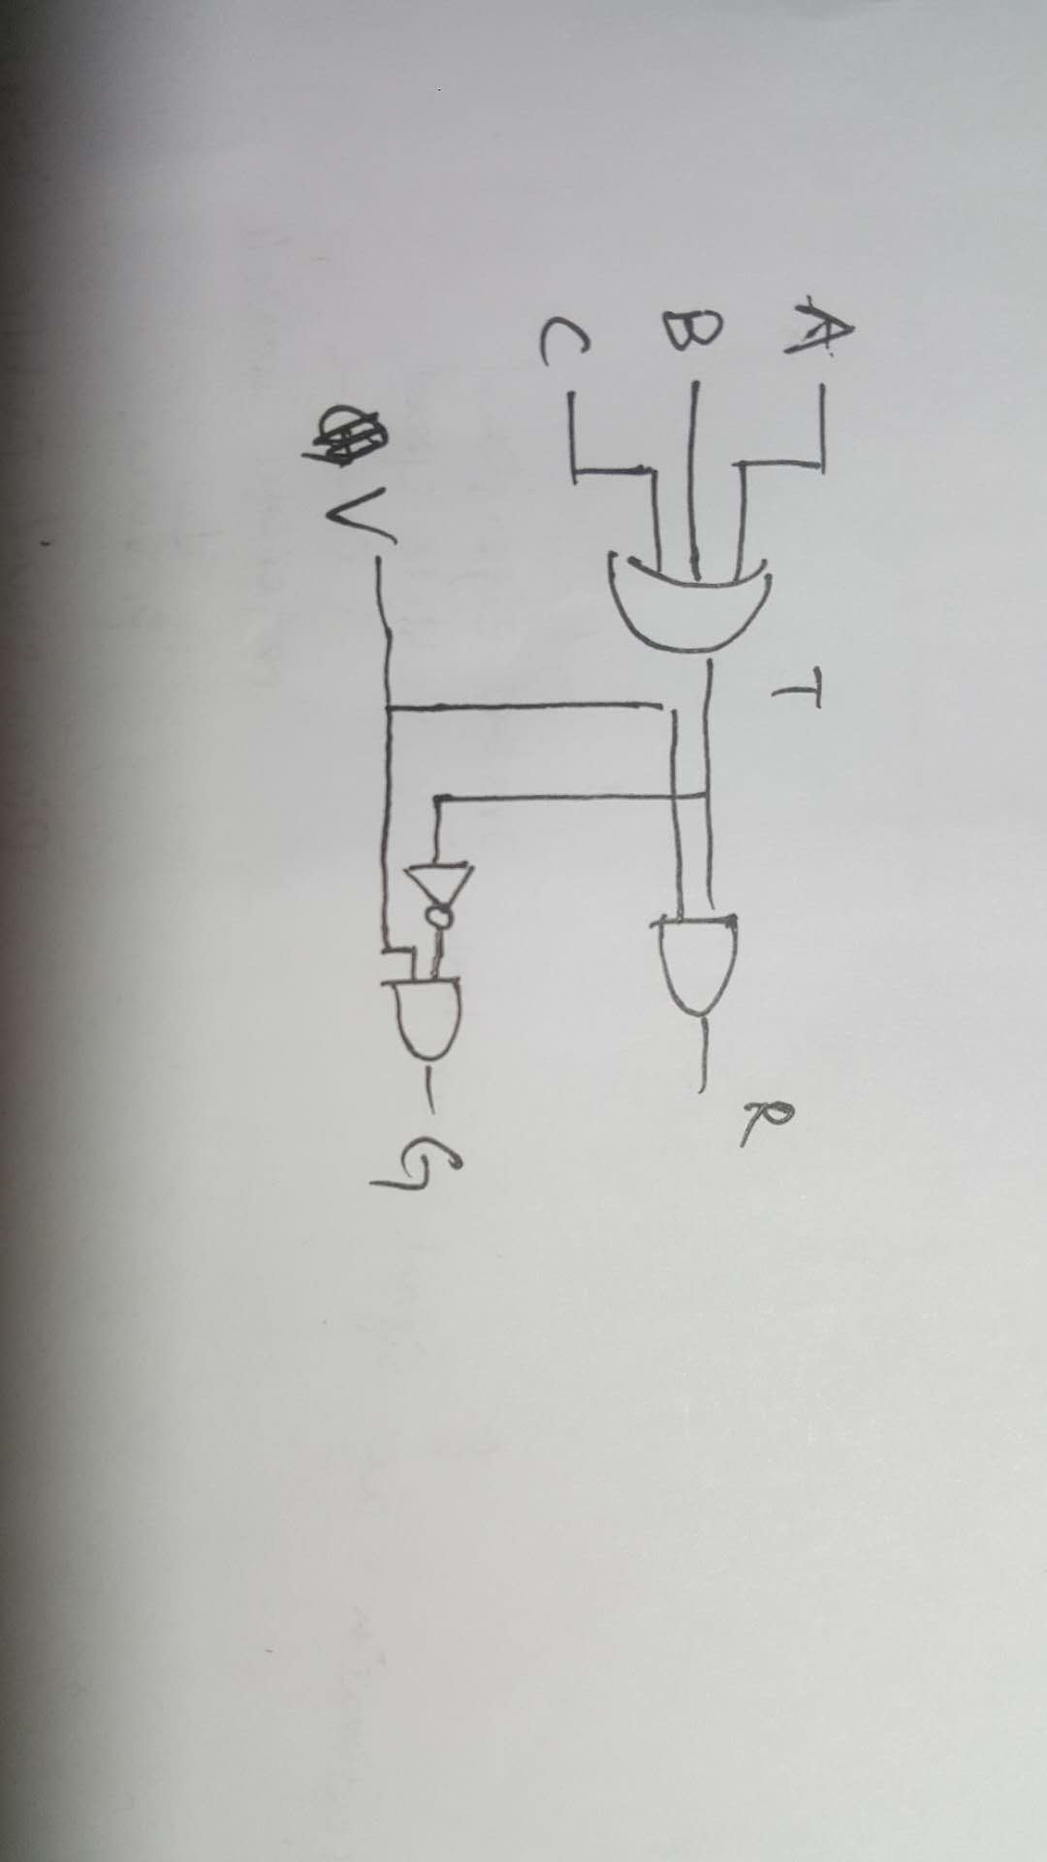

use 2-input nand gate:

3-input **or** gate *1: 2-input **or** gate *2 -> 2-input **nand** gate *6

2-input **and** gate *2: 2-input **nand** gate *4

Inverter *1: 2-input **nand** gate *1

Total: 2-input **nand** gate *11

red led *1: <https://uk.farnell.com/multicomp/mclf056md/led-blinking-5mm-high-red/dp/1581192?st=red%20flashing%20led>

green led *1: <https://uk.farnell.com/multicomp/mcl034gd/led-3mm-70-green/dp/1581114?st=green%20led>

NAND Gate *3: <https://uk.farnell.com/texas-instruments/cd4011be/ic-4000-cmos-4011-dip14-18v/dp/1106098?st=3%20input%20and%20gate>

*All the components are sold for a minimum amount of 5